COMP 7500 – Lecture 21a: Advanced Topics in Page Tables
: >85%, : 70-85%, : 55-70%, : 40-55%, : < 40%

Exercise 1: What happens if two page numbers are hashed to the same location?

Exercise 2: Answer the following two questions on the algorithm of hashed page tables.
- What is VPN?
- What is faulting_tag?
- What is ptr->mapping?
- When will function pagefault()be invoked?
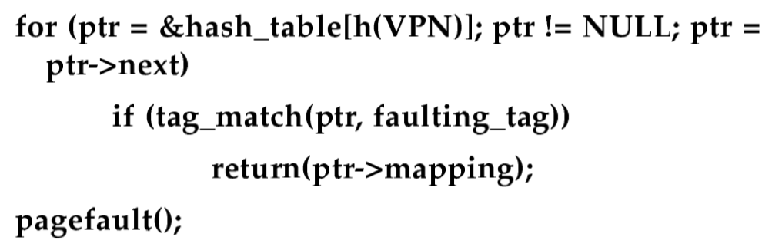
Exercise 3: Suppose the hash function is h(p) = p mod m, where p is the page number, m is the number of entries in a page table.
- What is the frame number of page 35?
- What is the frame number of page 12?
- What is the frame number of page 8?
- Which page number is listed in the wrong chain?
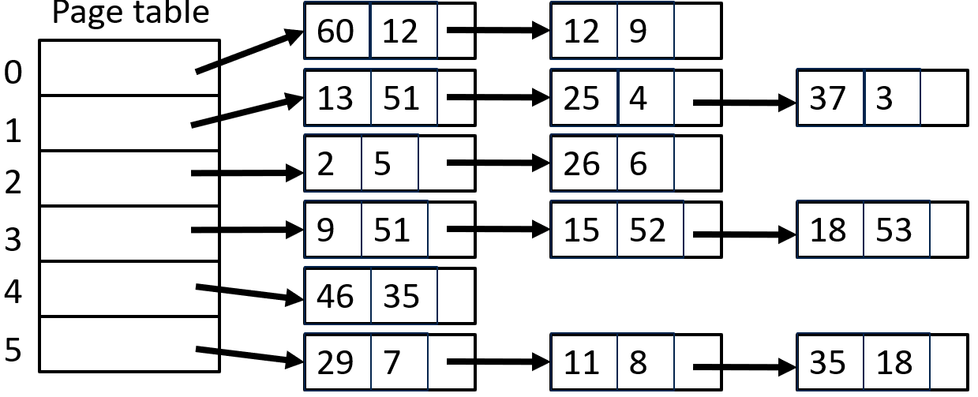

COMP 7500 Lecture 21b Mock Midterm Exam
Exercise 1 (Menti): What is the script command line used in project 1?
- To list file names B) To save a session of your terminal
- To compile your programs D) To debuge your programs

Exercise 2 (Menti): Shared memory is far more common in operating systems than message passing in distributed computing systems.
- True B) False

Exercise 3 (Menti): Message-passing systems are typically implemented using system calls.
- True B) False

Exercise 4 (Menti): Which one of the following write statements is correct for UNIX pipes?
- write(my_pipe[1], message, strlen(message));
- write(my_pipe[0], message, strlen(message));
- write(my_pipe[0], message, strlen(message)+1);
- write(my_pipe[1], message, strlen(message)+1);

Exercise 5 (Menti): Which one of the following close statements is correct?
- close(my_pipe[1], error); B) close(my_pipe[2]);
- close(my_pipe[0]); D) close(my_pipe[1], NULL);
Exercise 6 (Menti): How to calculate turnaround time?
A) Turnaround_time = Burst_time – Submission_time B) Turnaround_time = Finish_time – Arrival_time
C) Turnaround_time = Wait_time – Submission_time D) Turnaround_time = Wait_time – Burst_time

Exercise 7 (Menti): How to calculate wait time?
A) Wait_time = Burst_time – CPU_time B) Wait_time = Finish_time – CPU_time
C) Wait_time = Turnaround_time – Burst_time D) Wait_time = Finish_time – Burst_time

Exercise 8 (Menti): ____ is the number of processes that are completed per time unit.
A) CPU utilization B) Response time C) Turnaround time D) Throughput

Exercise 9 (Menti): Which of the following scheduling algorithms must be nonpreemptive?
A) SJF, B) RR C) FCFS D) priority algorithms

Exercise 10 (Menti): What is the pthread_join()function?
A) To wait for its child thread to complete. B) To wait for its parent thread to complete.
C) To wait for its brother thread to join. D) To join the parent thread after its execution is done

Exercise 11: Let’s consider the following processes. (1) Show the scheduling order of the processes using a Gantt chart when we apply the preemptive EDF (a.k.a., Earliest Deadline First) scheduling algorithm. (2) What is the finish time of each process? (3) What is the turnaround time for each process? (4) What is the wait time for each process? (5) Which process miss its deadline?
Processes | Arrival Time | Deadline | Burst Time
P1 | 0 | 13 | 10
P2 | 4 | 11 | 5

Exercise 12: Let’s consider the following processes. (1) Show the scheduling order of the processes using a Gantt chart when we apply the non-preemptive priority scheduling algorithm. (2) What is the turnaround time for each process? (3) What is the wait time for each process? (1 – Highest Priority, 5 – Lowest Priority)
Processes | Arrival Time | Priority | Burst Time
P1 | 0 | 5 | 10
P2 | 4 | 3 | 5
P3 | 9 | 2 | 20
P4 | 18 | 1 | 3

Exercise 13: Consider the following code segment:
pid t pid;
pid = fork();
if (pid == 0) /* child process */
fork();
fork();
How many unique processes are created?

